SWE30010 – Development Project 2: Design, Planning and Management

Learning Summary Report

Adam Bubonya (9986677)

**Submission Due**

Pass / Credit Portfolio: 6 June 2016 (Monday) 9:00am

Distinction / High Distinction: 13 June 2016 (Monday) 9:00am

**Portfolio Interview Dates**

Distinction / High Distinction: 14 – 17 June 2016 (1 hour per student)

**[Optional, but Recommended] Timing for Tutor Feedback**

Pass / Credit Portfolio:

Your submission: 30th May 2016 (Monday) 9:00

Tutor Feedback: 1st June 2016 (Wed) 17:00

Your revision and final submission: 6th June 2016 (Monday) 09:00

Distinction / High Distinction: 14 – 17 June 2016 (1 hour per student)

Your submission: 6th June 2016 (Monday) 9:00

Tutor Feedback: 8th June 2016 (Wed) 17:00

Your revision and final submission: 13th June 2016 (Monday) 09:00

Self-Assessment Details

The following checklists provide an overview of my self-assessment for this unit.

Table Self-assessment Statement

|  |  |  |  |  |
| --- | --- | --- | --- | --- |
|  | Pass (P) | Credit (C) | Distinction (D) | High Distinction (HD) |
| Self-Assessment (please tick) | ✔ |  |  |  |

Table Minimum Pass Checklist

|  |  |
| --- | --- |
|  | Included (please tick) |
| Learning Summary Report | ✔ |
| All Pass Tasks are Complete on Doubtfire | ✔ |

Table Minimum Credit Checklist, in addition to Pass Checklist

|  |  |
| --- | --- |
|  | Included (please tick) |
| All Credit Tasks are Complete on Doubtfire |  |

Table Minimum Distinction Checklist, in addition to Credit Checklist

|  |  |
| --- | --- |
|  | Included (please tick) |
| Interview booked |  |
| All Distinction Tasks are Complete on Doubtfire |  |
| Other pieces (please specify) |  |

Table Minimum High Distinction Checklist, in addition to Distinction Checklist

|  |  |
| --- | --- |
|  | Included (please tick) |
| Software Project Report [Plan, Design, QA] meets HD standards |  |
| Research Article / Essay meets High Distinction standards |  |
| Other pieces (please specify) |  |

# Declaration

I declare that this portfolio is my individual work. I have not copied from any other student’s work or from any other source except where due acknowledgment is made explicitly in the text, nor has any part of this submission been written for me by another person.



Signature:

# Introduction

This report summarises what I learnt in SWE30010 Development Project 2. It includes a self-assessment against the criteria described in the unit outline, a justification of the pieces included, details of the coverage of the unit’s intended learning outcomes, and a reflection on my learning.

# Overview of Pieces Included

This section outlines the pieces that I have included in my portfolio…

1. Task 1.1 - *Shows the process of a Sprint Planning Meeting.*
2. Task 1.2 - *Development of a Project Backlog and Business Values*
3. Task 2.1 - *Start of group work – Worked out dependencies of upcoming sprint, and product backlog.*
4. Task 2.2 - *Constructed Time Frames for backlog, created a table displaying dependencies*
5. Task 3.2 - *Demonstrated implementation of Burndown charts as well as Trello.*
6. Task 4.2 - *Sprint 1 Progress Reports with Trello and Burndown Charts.*
7. Task 5.2 - *Worked out issues and problems with the last sprint. Discussed problems.*
8. Task 5.3 - *Sprint Review, discussed processes that worked and what did not work.*
9. Task 5.4 - *Sprint Retrospective, end team velocity demonstration, team process and discussion of team expectations.*
10. Task 6.2 - *Definition of Done, what our group deemed as ‘complete’.*
11. Task 6.3 - *Trello and what happened in the previous sprint*
12. Task 6.4 - *Task updates and Burndown Chart.*
13. Task 7.2 - *Sprint 2 - Week 1 minutes and burndown charts.*
14. Task 8.2 - *Sprint 2 – Week 2 minutes and burndown charts.*
15. Task 8.3 *- Product Review, demo functionality and completed items/improvements.*
16. Task 8.4 *- Team Velocity, process and performance for given sprint.*
17. Task 9.2 *– UML Diagram and project conclusion justifications*

# Coverage of the Intended Learning Outcomes

This section outlines how the pieces I have included demonstrate the depth of my understanding in relation to each of the unit’s intended learning outcomes. In particular, it includes work that demonstrates that I have achieved all Unit Learning Outcomes for SWE30010 Development Project 2 to a **Pass** level.

## ILO 1:

Apply techniques to define scope, break down tasks, estimate effort, manage risks, and schedule resources in the planning of a software development project

The following pieces demonstrate my ability in relation to ILO 1:

* Task 1.2 showed this as a good example. It was all about defining a scope, what information will be necessary for the learning outcome, and how to plan accordingly.
* Task 2.2 also demonstrated this well, constructing time frames helped determine the scope of the project.
* Task 6.2 aided with this learning outcome as we had a lot of planning to do based off our previous sprint.

## ILO 2:

Select, justify, and use appropriate design patterns, algorithms, data structures, and architectural styles to design a software solution

The following pieces demonstrate my ability in relation to ILO 2:

* Task 9.2 was perhaps one of the best examples. It was purely a design for a solution and included great summary data detailing the whole project.

## ILO 3:

Utilise contemporary tools and techniques to document software artefacts, and track and report project progress

The following pieces demonstrate my ability in relation to ILO 3:

* Task 2.2 showed how to utilize tools quite effectively as we had to actually get ‘dirty’ and work with a real world scenario to get things working.
* Task 3.2 was very similar and demonstrated this learning outcome.
* Task 5.4 helped with reporting too with similar tools used for outcome 4.
* Task 6.3 demonstrated this as well with Trello and discussions on previous sprint.
* Task 6.4 aided in this learning outcome as well, for similar reasons to 6.3.

## ILO 4:

Apply and use contemporary tools and techniques to work effectively as a member of a software development team, and reflect upon group work experience

The following pieces demonstrate my ability in relation to ILO 1:

* Task 1.1 demonstrated this well. It was essentially an overview of how to plan meetings and participate in a well-structured manner.
* Task 2.1 partially demonstrated this as it was one of the first tasks where we had to effectively work as a team.
* Task 5.4 also demonstrated this with our sprint retrospective, showing our velocity and team process.

## ILO 5:

Review the quality of a software product based on a chosen quality model / framework with justifications

The following pieces demonstrate my ability in relation to ILO 5:

* Task 5.3 was a strong demonstration of implementing ILO 5. It was all about working out issues with our last sprint, which aided in review.
* Task 6.2 also gave clarity into the review process.
* Task 8.3 was all about reviewing our product and demo functionality.

# Reflection

## The most important things I learnt:

I really enjoyed learning about the very concept of Sprint meetings. I have never done anything like that, especially in the discussions from our previous SDP subject, which was quite lacking.

Being able to do something with it was very useful and will aide me in my life in the workforce for the near future.

## The things that helped me most were:

The group work helped me a lot – being able to see how one of my group members Linh did things aided me considerably.

My Tutor’s advice was also quite helpful and in the review process for portions of our sprint, he provided some very nice information.

## I found the following topics particularly challenging:

The daily meetings took quite some time to get used to. During the first sprint, I found myself slacking off quite a lot and barely making it on time to the meetings. After realising how necessary it was in the review portion, our second sprint went much better because of it.

I am glad we had to do two sprint sessions. Without it, I think I would not have enjoyed or liked the process at all.

## I found the following topics particularly interesting:

Actual implementation was quite fun. I am glad expectations for what we could make were not too over the top for us. It was strange trying out a way of managing a project in such a manner and I am glad I participated in the subject.

## I feel I learnt these topics, concepts, and/or tools really well:

Scrum Sprints are a very useful thing to know how to implement and I definitely plan to use it at work in the future.

## I still need to work on the following areas:

I think I need more work on actually organising the sprint meetings nightly as well as trying to promote people to join in. We often had one member missing a meeting every now and then.

I could also record the meeting minutes in a better way – I feel they lack depth now.

## My progress in this unit was …:

To be blunt, very poor. Our group was caught up in the actual project side that we neglected to actually work on the documentation/tasks. In the end, we caught up but it definitely showed a decline in quality.

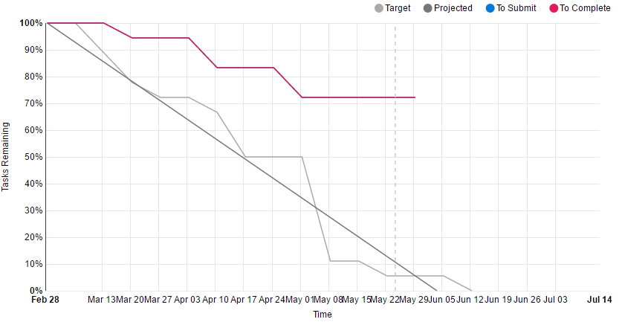

## This unit will help me in the future:

I am excited to use this for larger projects at work. If I had done this with my team earlier in the year I think our implementation of an application, called Citrix would have gone much smoother.

## If I did this unit, again I would do the following things differently:

Approach the Tasks with a bit more enthusiasm. They are a bit lacking in detail and I think realistically I should have aimed for a distinction, and could have if I had started the tasks earlier.